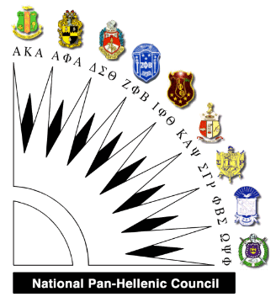 | To: College-Bound High School Seniors  From: National Pan-Hellenic Council,  Clarksville Chapter  Re: Scholarship Opportunity

The Greater Clarksville National Pan-Hellenic Council (NPHC) is now accepting applications for our 2018-2019 NPHC Scholarships. Our scholarships are available to qualifying high school seniors enrolled in the Clarksville-Montgomery County School System who plan to continue their education after graduation.

The 2018-2019 NPHC scholarships will be awarded to first-place ($600.00) and second-place ($400.00) winners. The scholarship committee will thoroughly review each application packet received to determine the first and second-place winners. Notification will be sent to the winners via mail no later than April 1, 2018.The scholarships will be made payable to the respective university or college in the recipient's name upon receipt of enrollment verification.

The following items are required by Thursday, March 15, 2018 in order to be considered for our 2018-2019 NPHC Scholarships:

- Completed Scholarship Application
- 1-2 Page Essay (Topic: “Why I Should Be Awarded a 2018-2019 NPHC Scholarship”)
- Letter of Recommendation (from applicant’s school administrators, faculty or guidance counselor)
- Official Transcripts (student MUST have an overall 3.0 GPA or higher)

Any questions should be directed to the National Pan-Hellenic Council Scholarship Chairperson, Michael L. Peeler, at GreaterClarksvilleNPHCScholar@gmail.com.

Please send the completed application to the address below by March 15, 2018:

National Pan-Hellenic Council
Attn: Scholarship Committee
P. O. Box 466
Clarksville, TN 37041-0466

NATIONAL PAN-HELLENIC COUNCIL- CLARKSVILLE CHAPTER
SCHOLARSHIP APPLICATION

Return by 03/15/2018 Application Date _________ HS Graduation Date ________

Name_________________________________________________________________
Last First Middle

Date of Birth Ethnicity

Street Address __________________________________ Phone

City, State ____________________________________ Zip

E-mail Address: ______________________________________________

Desired College Major Minor

Total HS credit hours completed as of December 2017________ GPA

PLEASE ENCLOSE ONE COPY OF YOUR OFFICIAL TRANSCRIPT WITH THIS APPLICATION.

Discipline infractions this academic year (circle one) YES NO

If YES, please explain:

List awards and honors you have received: ______________________________________________________________________________

List organizations to which you belong and offices you held:

In this space describe your career plans:

Describe briefly any community service performed:

Aside from a college degree, what do you hope to gain from your college experience?

