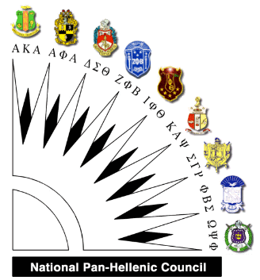 | To: College-Bound High School Seniors  From: National Pan-Hellenic Council,  Clarksville Chapter  Re: Scholarship Opportunity

The Scholarship Committee of the Clarksville National Pan-Hellenic Council is accepting applications for the Annual Scholarship Program for school year 2016-17. The scholarship is available to qualifying high school seniors enrolled in a Clarksville-Montgomery County school.

This scholarship is for $500 and is payable to the university or college in the student's name upon verification of enrollment.

The following documents are needed to submit the application to the National Pan-Hellenic Council by April 28, 2017:

- Completed Scholarship Application Form
- An Official Transcript of courses and grades
- GPA 3.0 or Higher

Members of the committee will review application packets to select two scholarship recipients. Notification of scholarship award will be received by mail no later than April 28, 2017.

Any questions should be directed to the National Pan-Hellenic Council Scholarship Chairperson, Kathrine Bailey, at 931-933-1801.

Send completed application by April 28, 2017 to:

National Pan-Hellenic Council
Attn: Scholarship Committee
P. O. Box 466
Clarksville, TN 37041-0466

NATIONAL PAN-HELLENIC COUNCIL- CLARKSVILLE CHAPTER
SCHOLARSHIP APPLICATION

Return by April 28, 2017 Application Date _________ HS Graduation Date ________

Name_________________________________________________________________
Last First Middle

Date of Birth Ethnicity

Street Address __________________________________ Phone

City, State ____________________________________ Zip

E-mail Address: ______________________________________________

Desired College Major Minor

Total HS credit hours completed as of April 2017________ GPA

PLEASE ENCLOSE ONE COPY OF YOUR OFFICIAL TRANSCRIPT WITH THIS APPLICATION.

Discipline infractions this academic year (circle one) YES NO

If YES, please explain:

List awards and honors you have received: ____________________________________________________

List organizations to which you belong and offices you held:

In this space describe your career plans:

Describe briefly any community service performed:

Aside from a college degree, what do you hope to gain from your college experience?

